Tosupplyleftoverfoodtopoor

COLLEGENAME: CHIKKANAGOVTARTSCOLLEGE, TIRUPUR. COLLEGECODE: asbru06

TEAMID: NM2025TMID26262

* TEAMMEMBERS:

TEAMLEADERNAME: CHANDRU S

EMAIL: [steeppenchandru@gmail.com](mailto:steeppenchandru@gmail.com) TEAMMEMBER1: SILAMBARASAN M

EMAIL: [silamparasanarasan96@gmail.com](mailto:silamparasanarasan96@gmail.com) TEAMMEMBER2: KAMALESH K EMAIL:

TEAMMEMBER3: DHANUSHN

EMAIL: [kuttydhanush20022006@gmail.com](mailto:kuttydhanush20022006@gmail.com) TEAMMEMBER4:SUNDHARAVELU M

EMAIL: [svel59789@gmail.com](mailto:svel59789@gmail.com)

# INTRODUCTION:

1.1PROJECTOVERVIEW:Ourprojectfocusesonconnectingsurplus/leftoverfoodfromhotels,functions,and householdstoneedypeople.

Food

collection

Awareness

&impact

quality&

safety check

Tosupplyleft

overfoodto poor

Tracking&

documenta tion

Packaging&

storage

Distributio

n& logistics

# DEVELOPMENT PHASE

CREATINGDEVELOPMENT ACCOUNT:

ByusingthisURL –<https://developer.salesforce.com/signup>

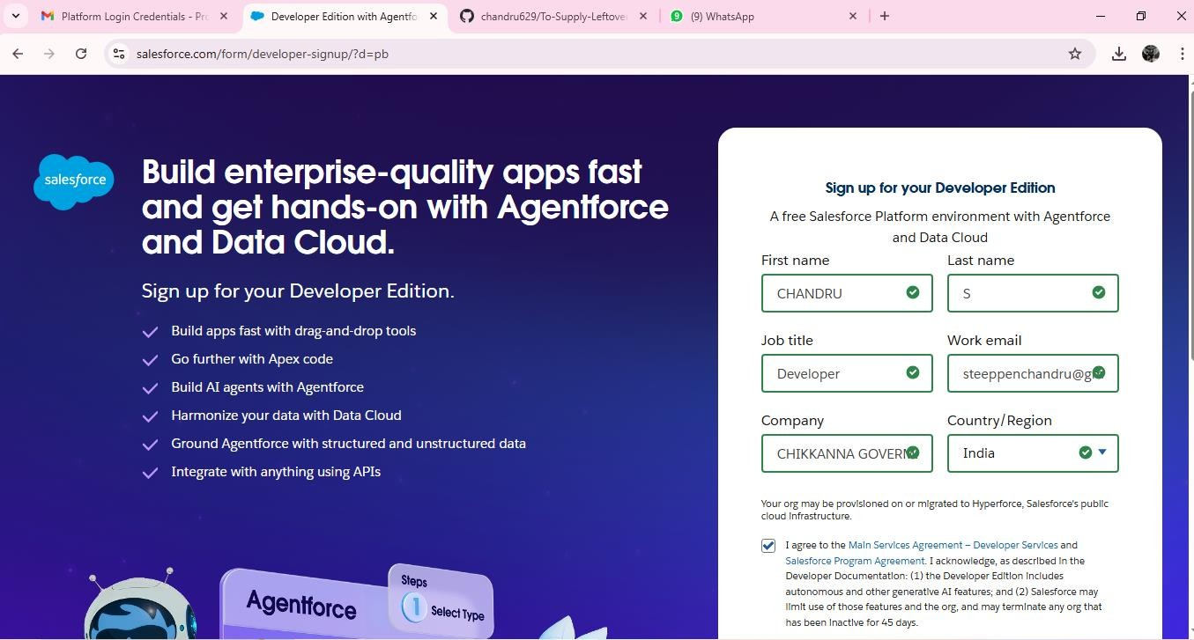

* Createdobjects:venue,dropofpoint,task,volunteer,execution detail

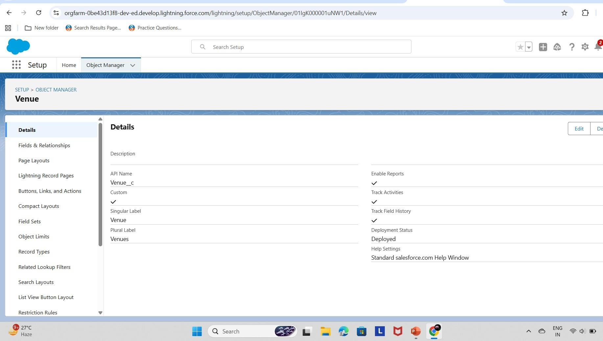

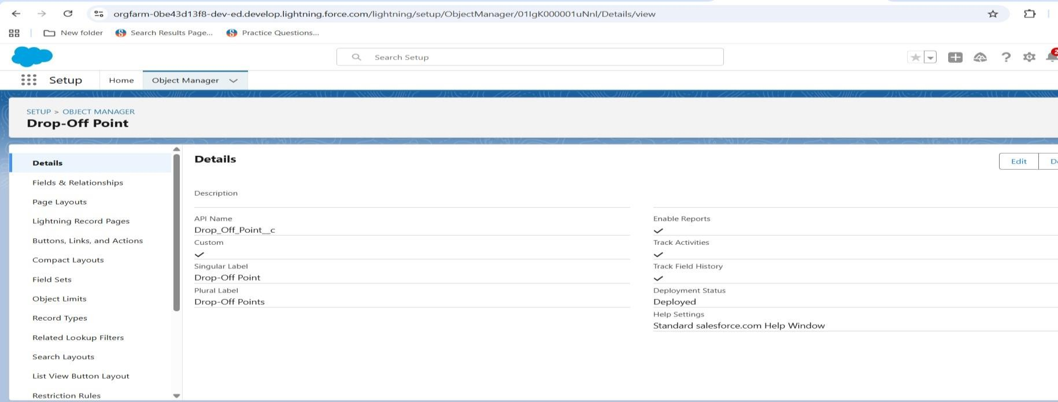

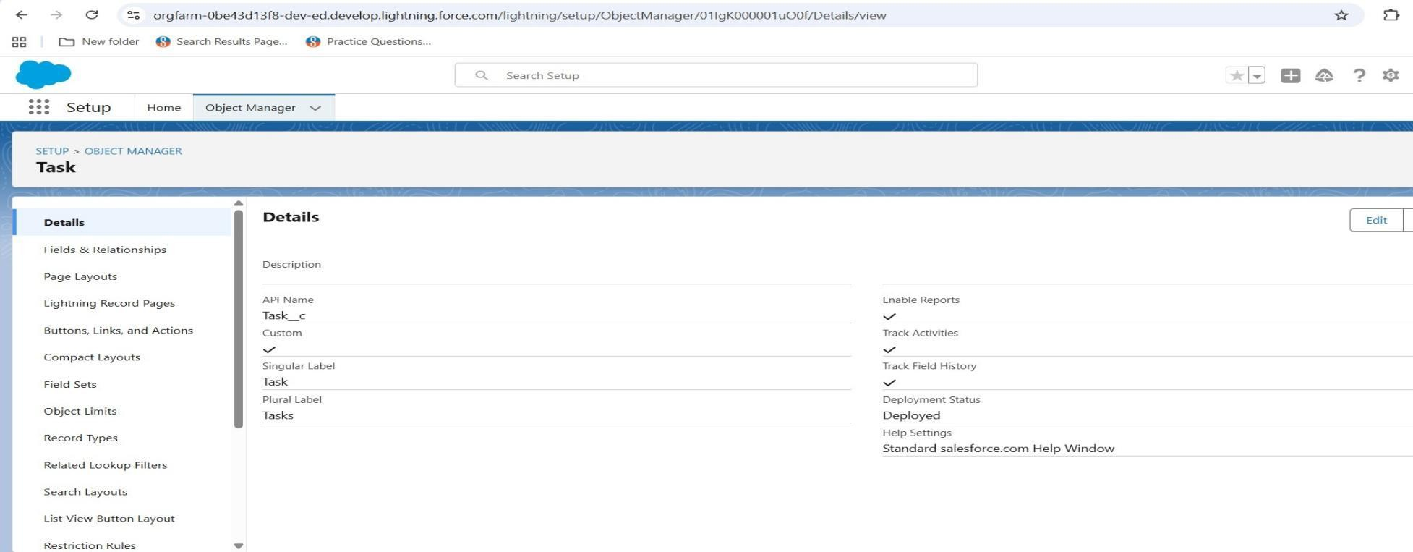

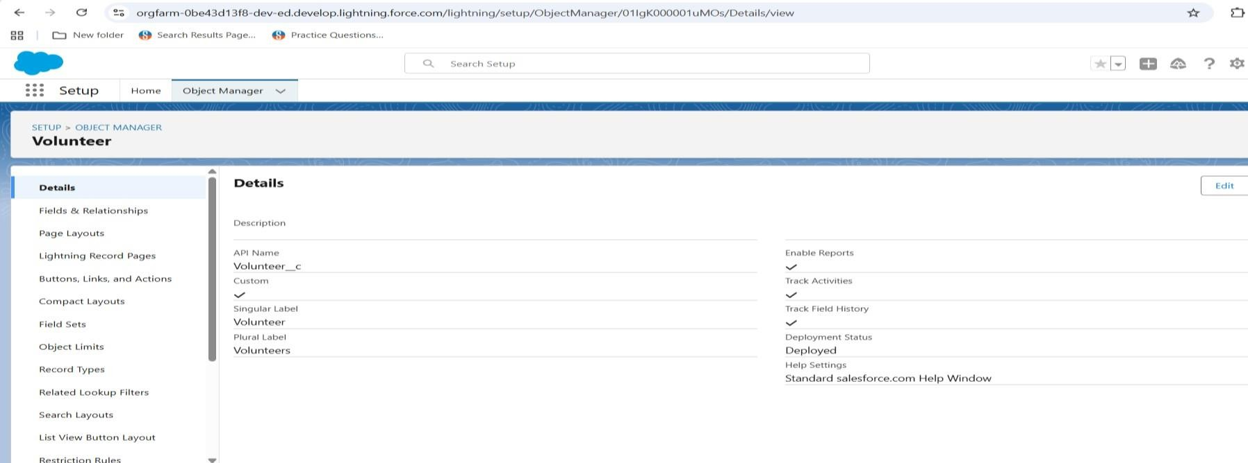

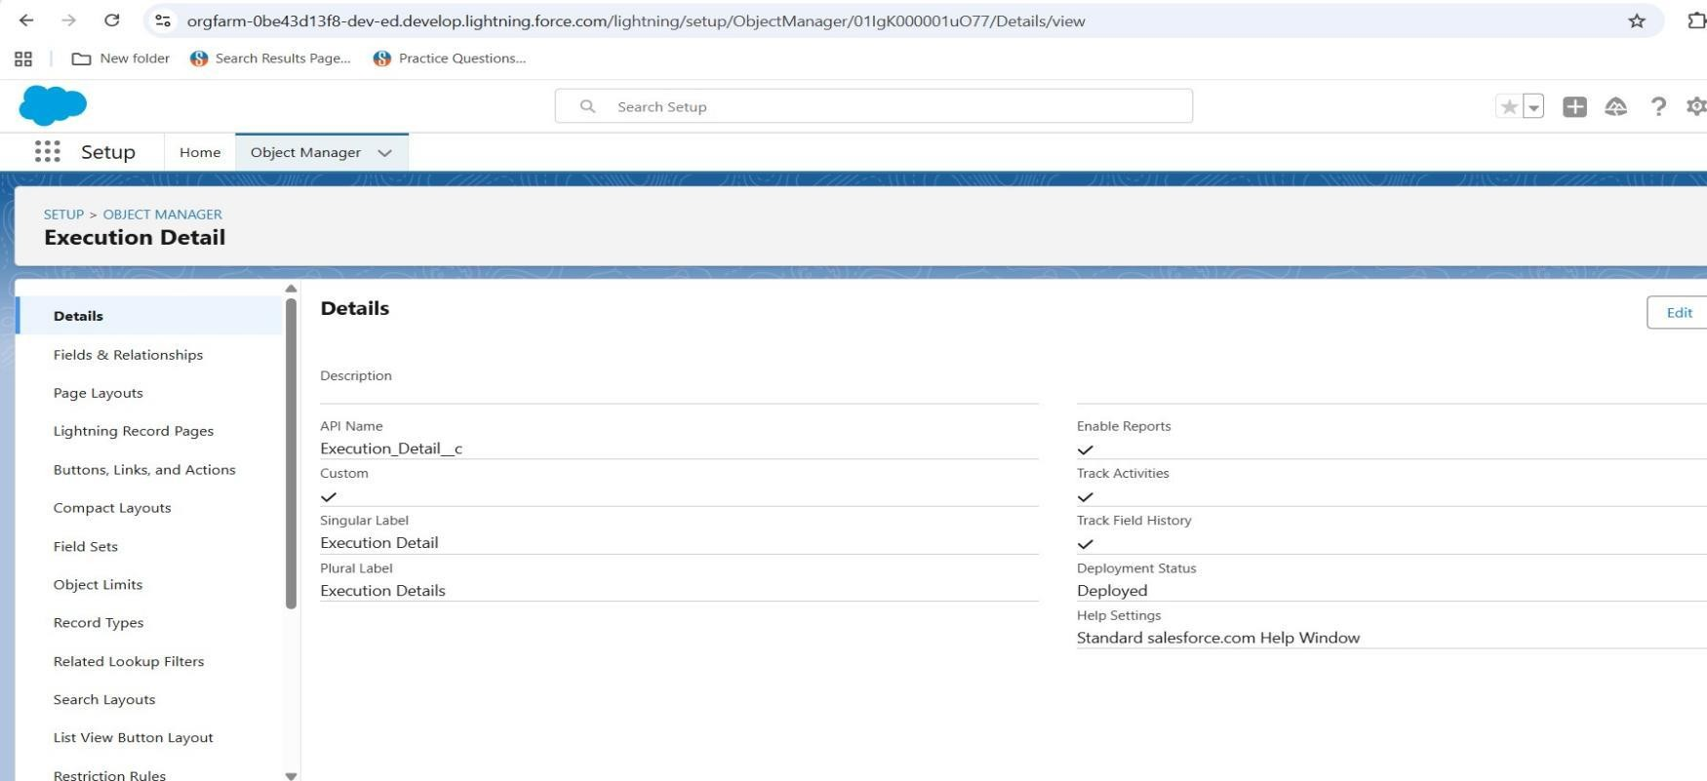

* + Configurefieldsandrelationship:

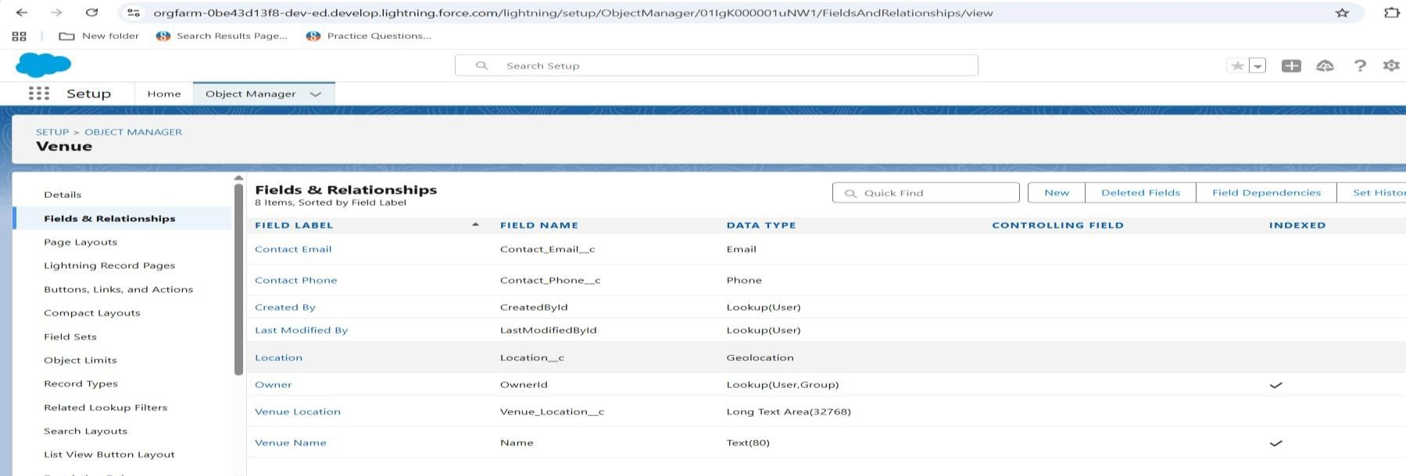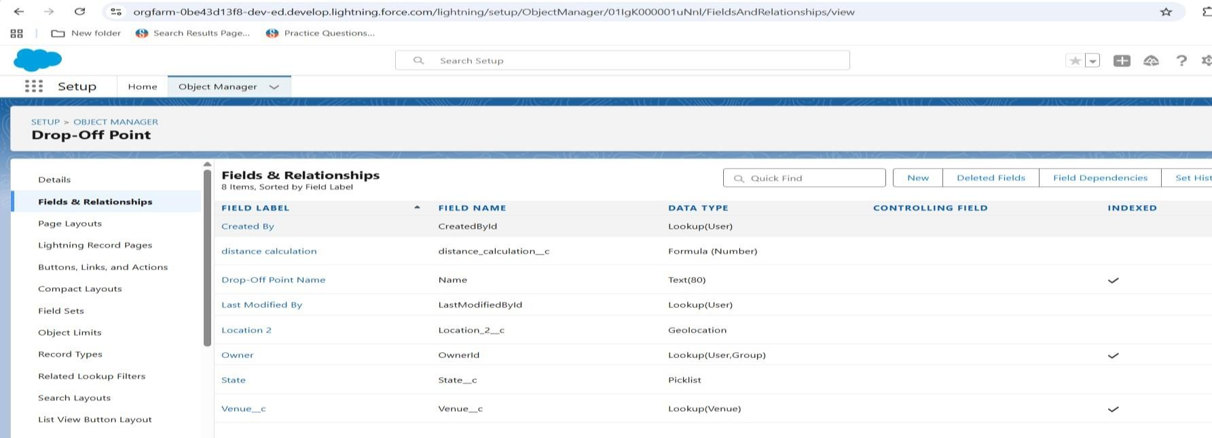

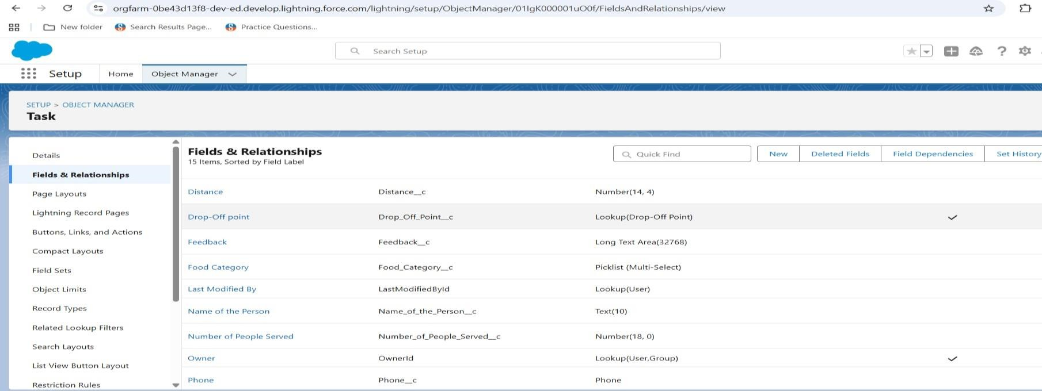

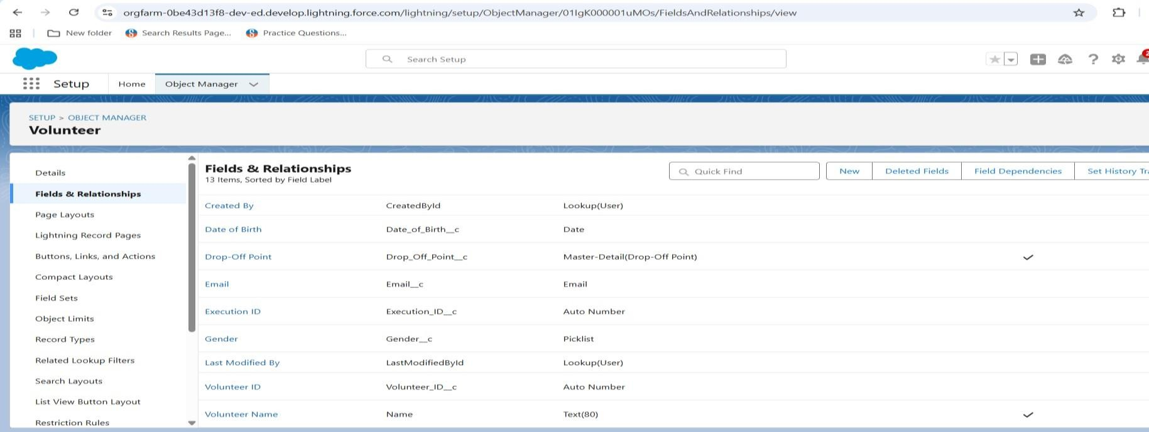

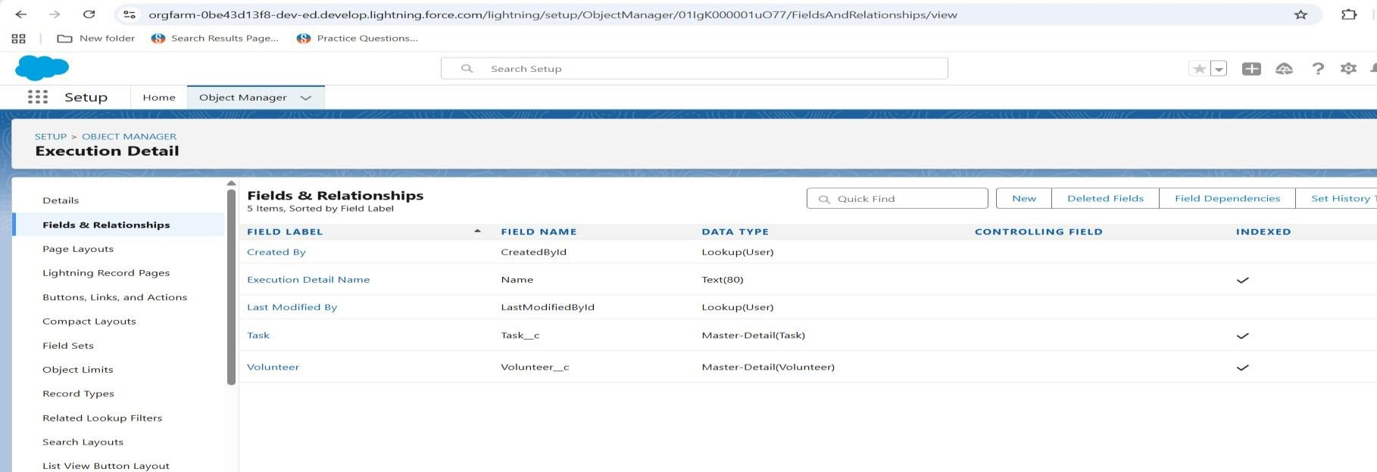

* + - DevelopmentLightningAppwithrelevanttabs:

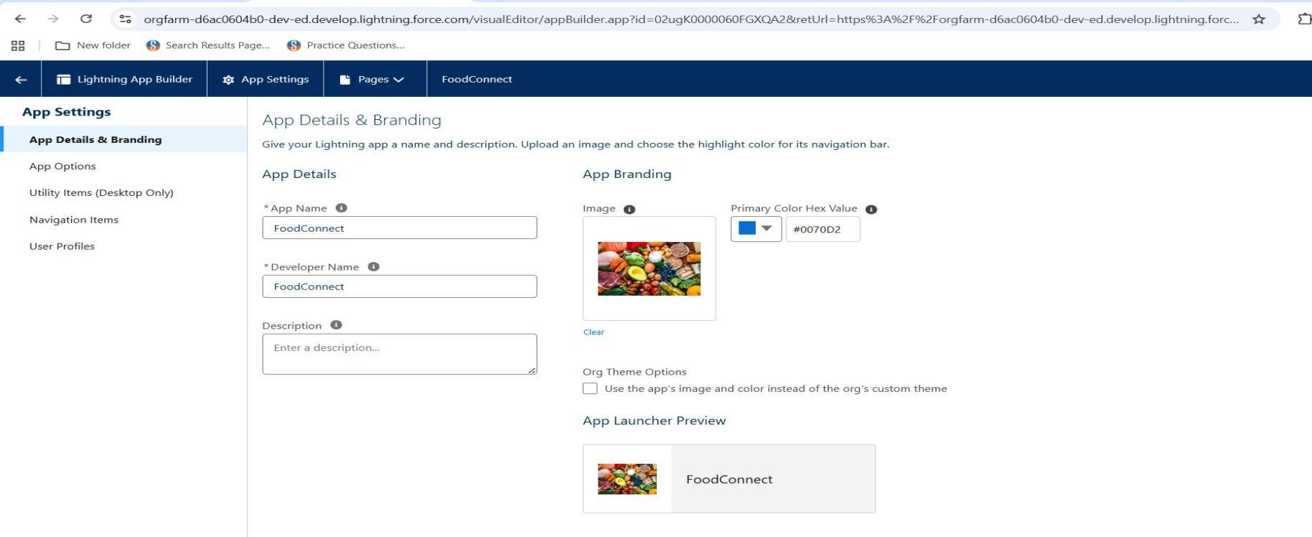

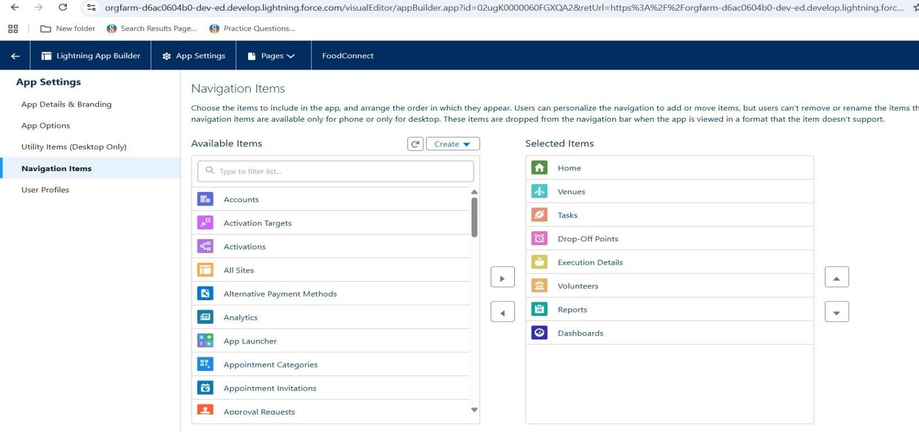

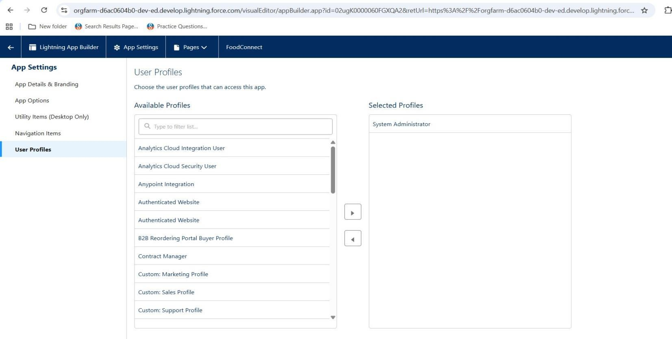

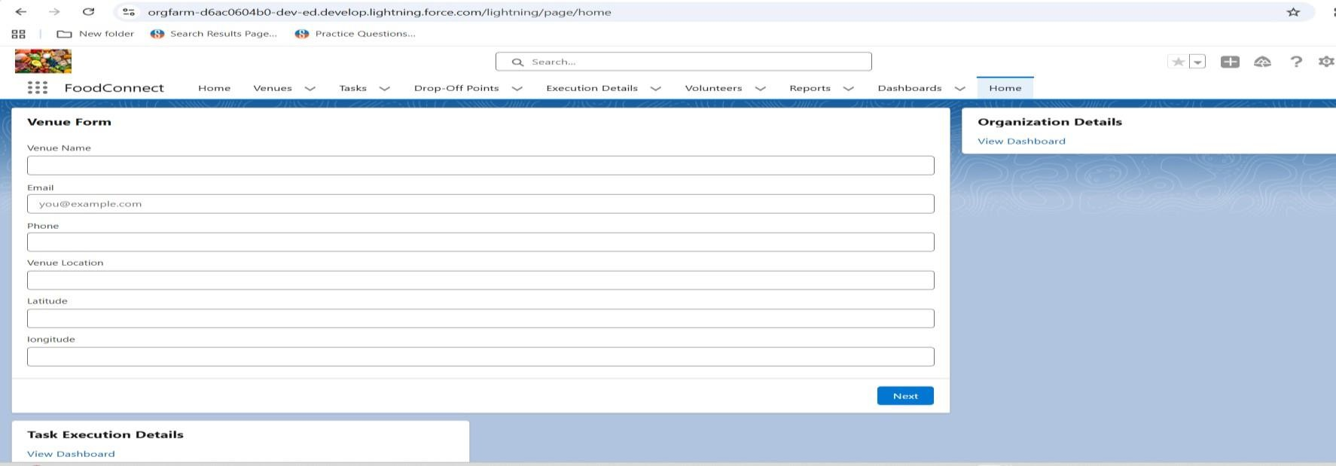

* + - 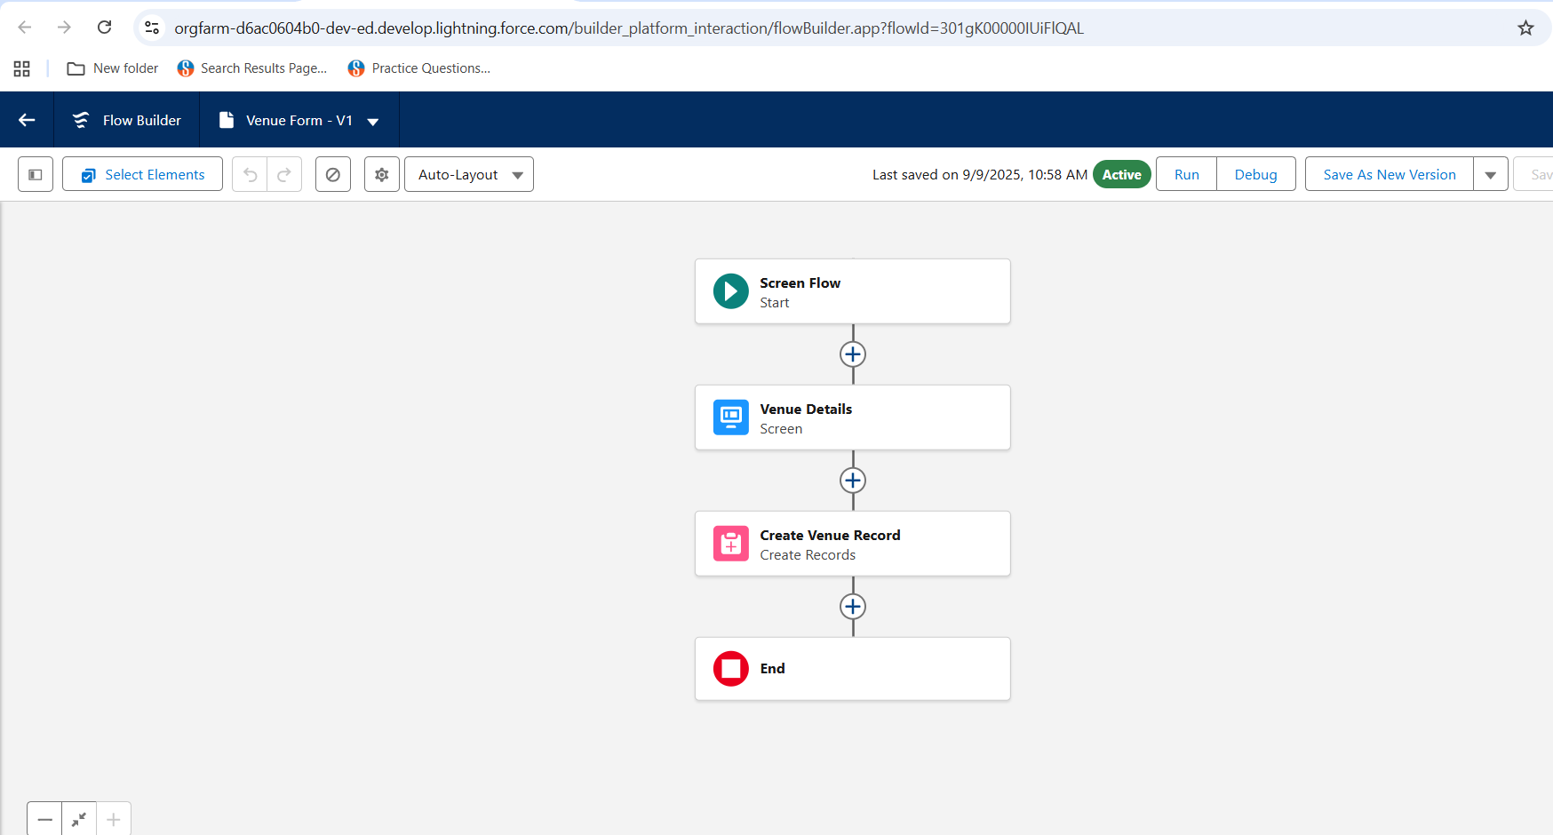Implementflows forvenuedetailsandcreatevenue record:
    - To createa fieldsforthedropof point:

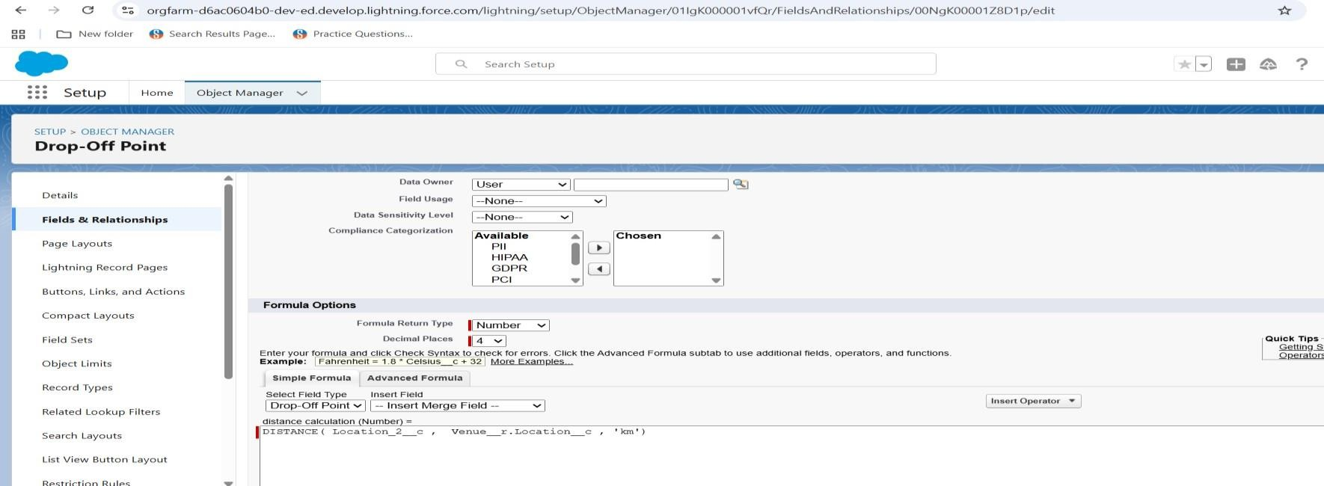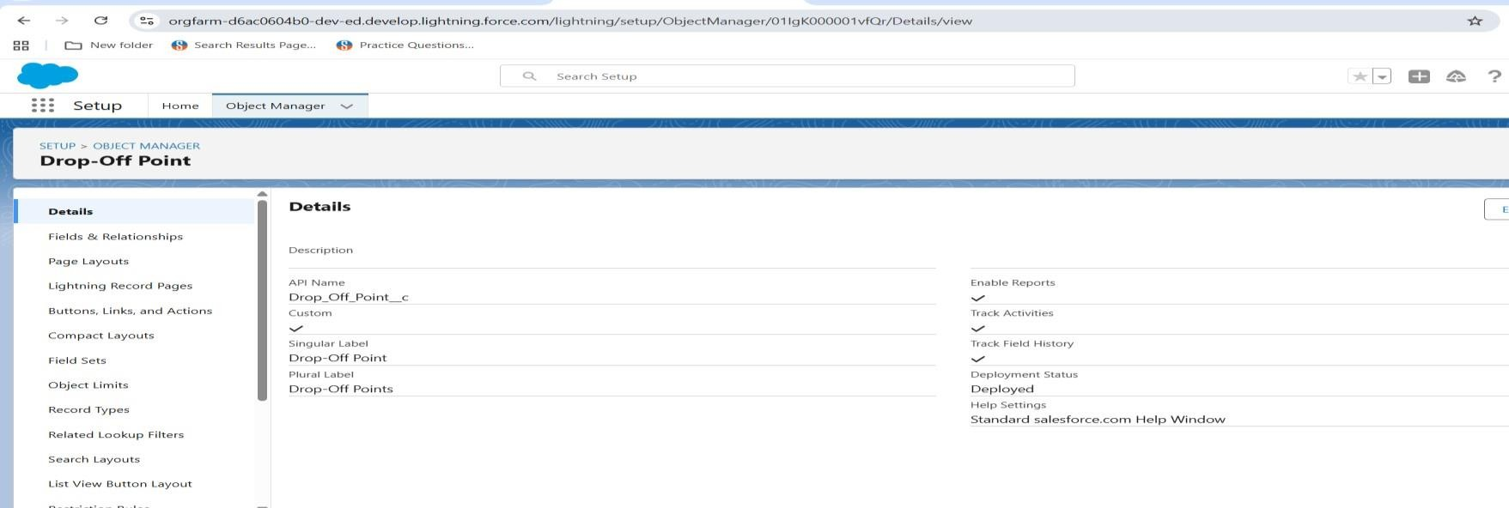

* + - 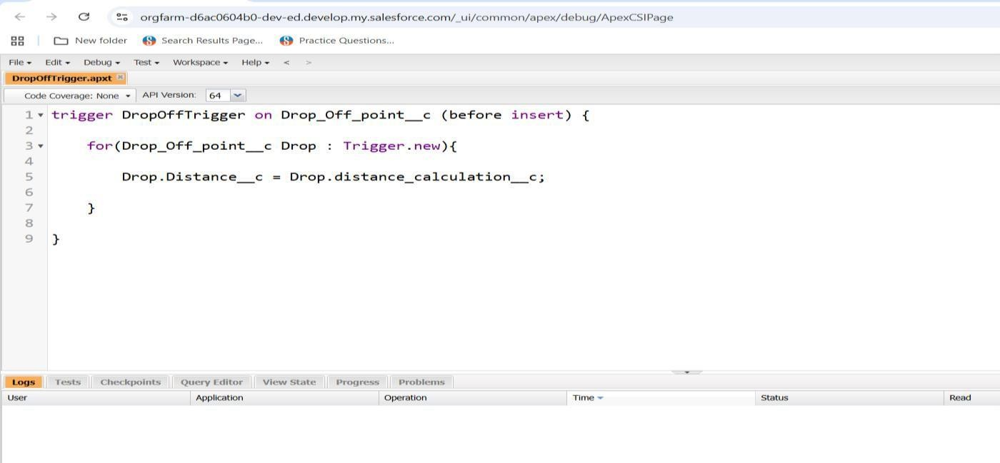Addedapextriggerforcoding:

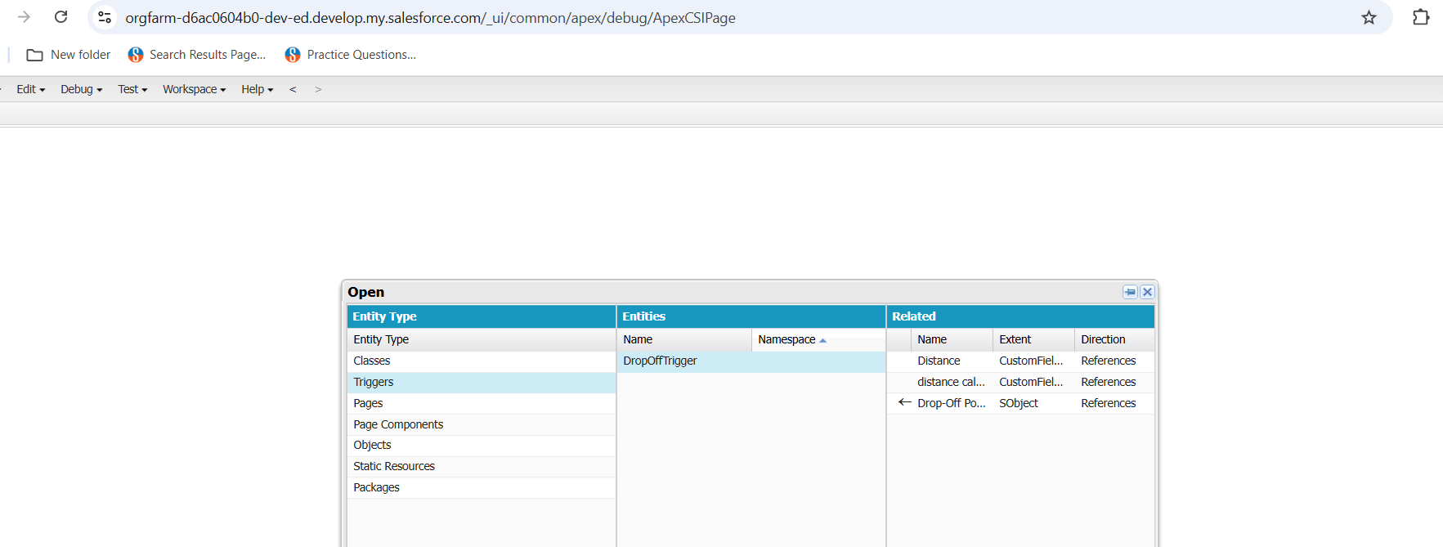

* + - 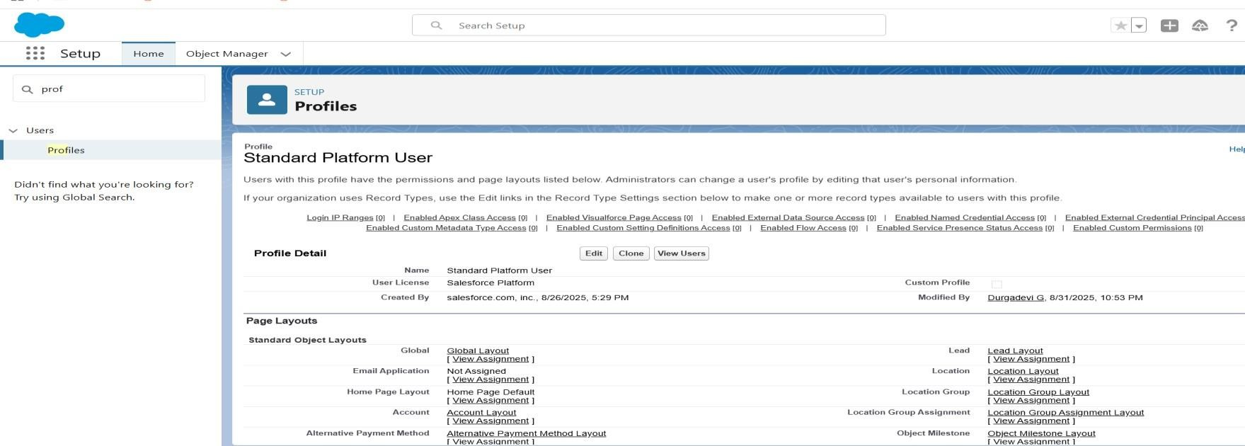Createtheprofilefor standardplatformuser:
      * User1creation:

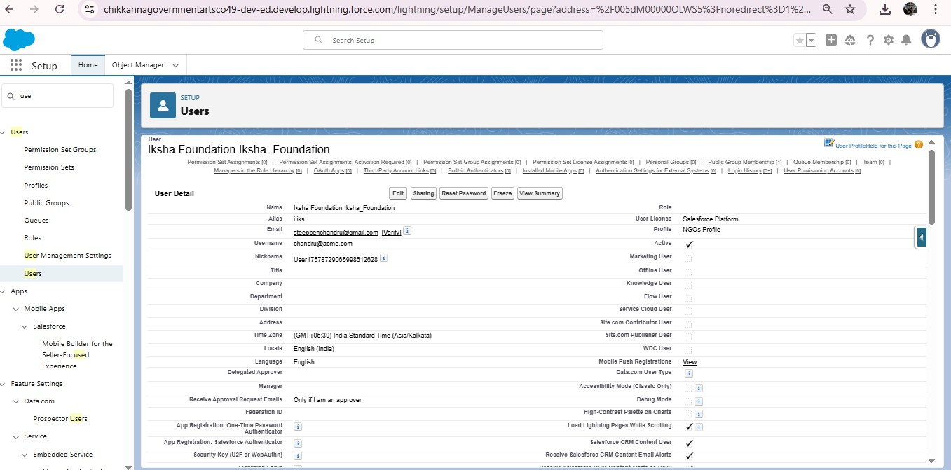

* + 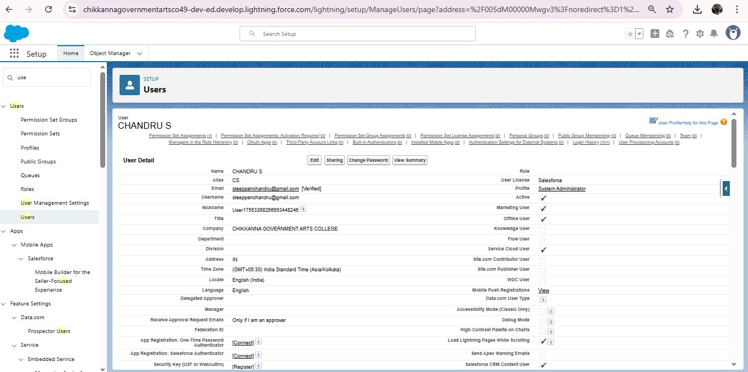User2&3creation:
  + Createthereporttype:

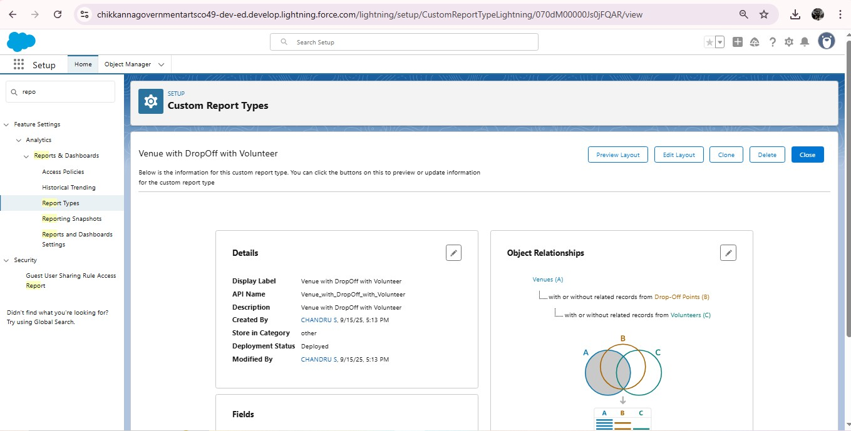

* Creationofreporton:venue withdropofwithvolunteer,executiondetails and task

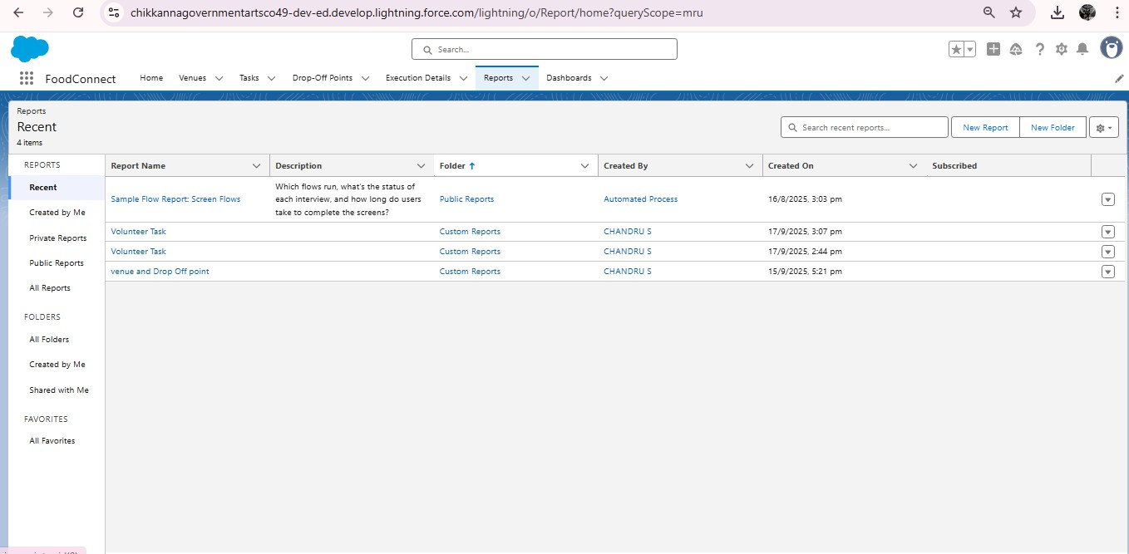

* Dashboardaddingfor:venueanddropofpoint,volunteertask&Apicturetothe dashboards

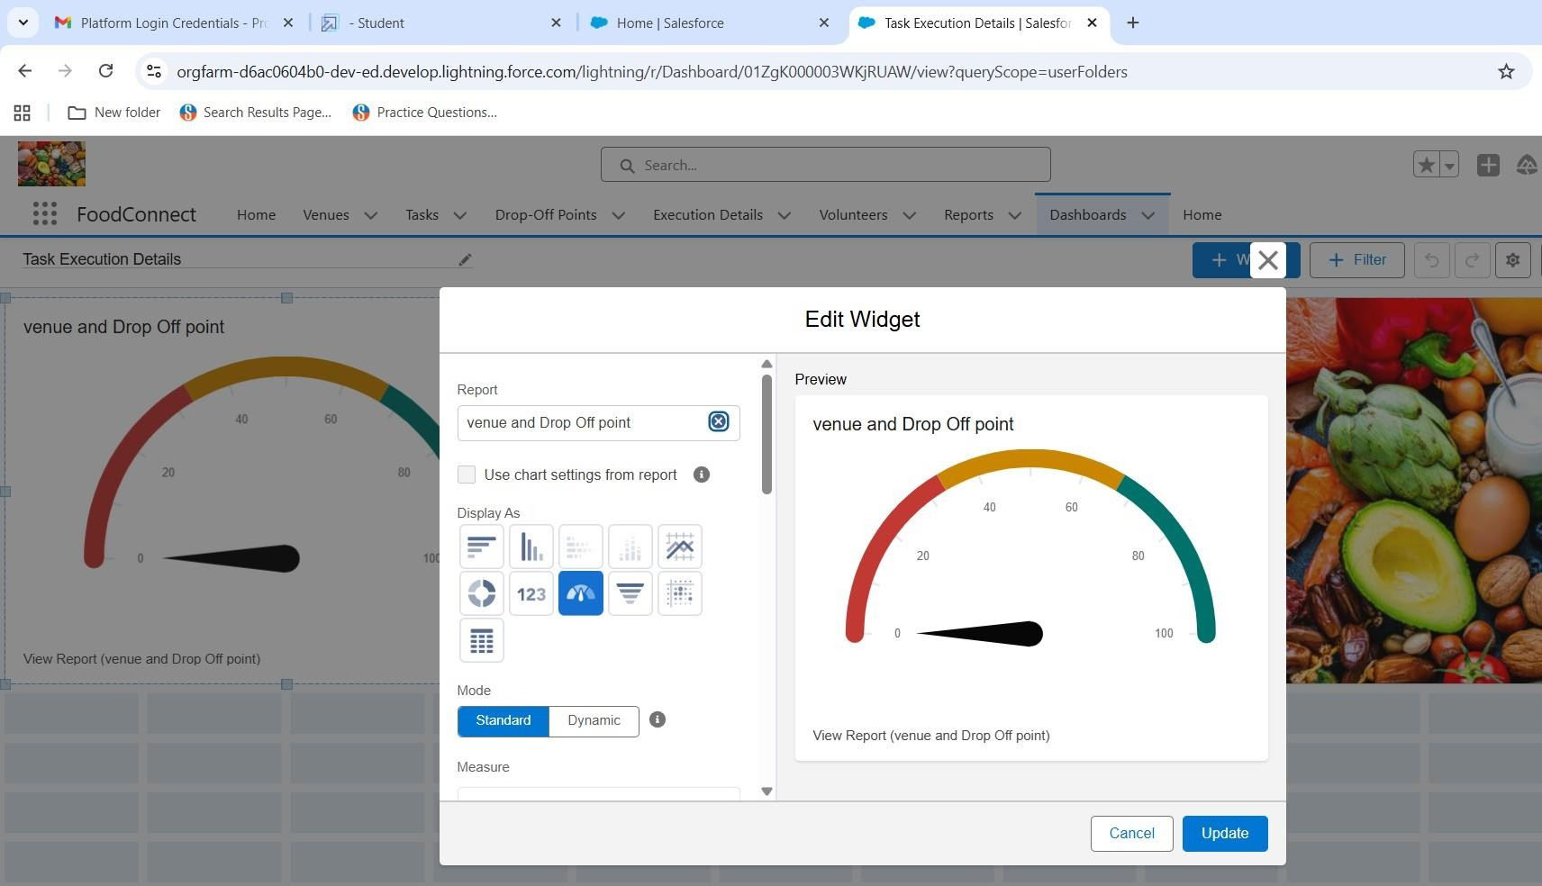

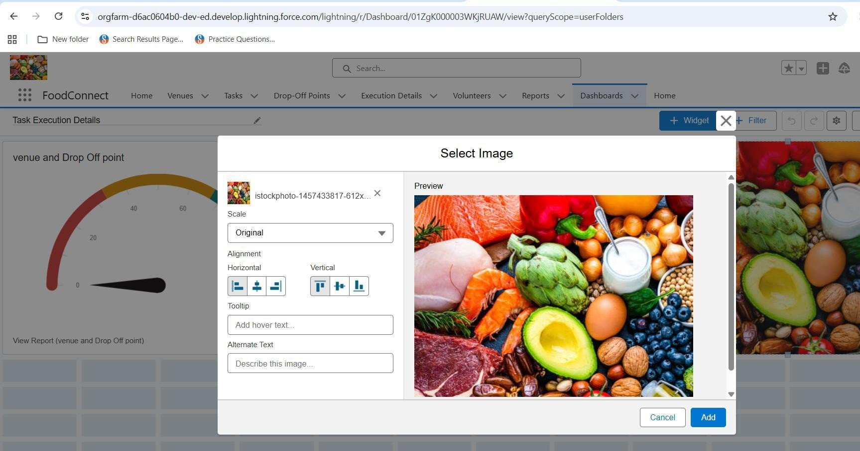

* + 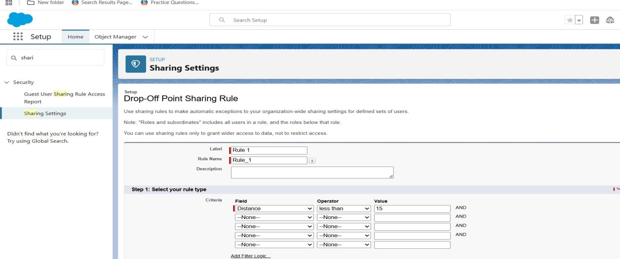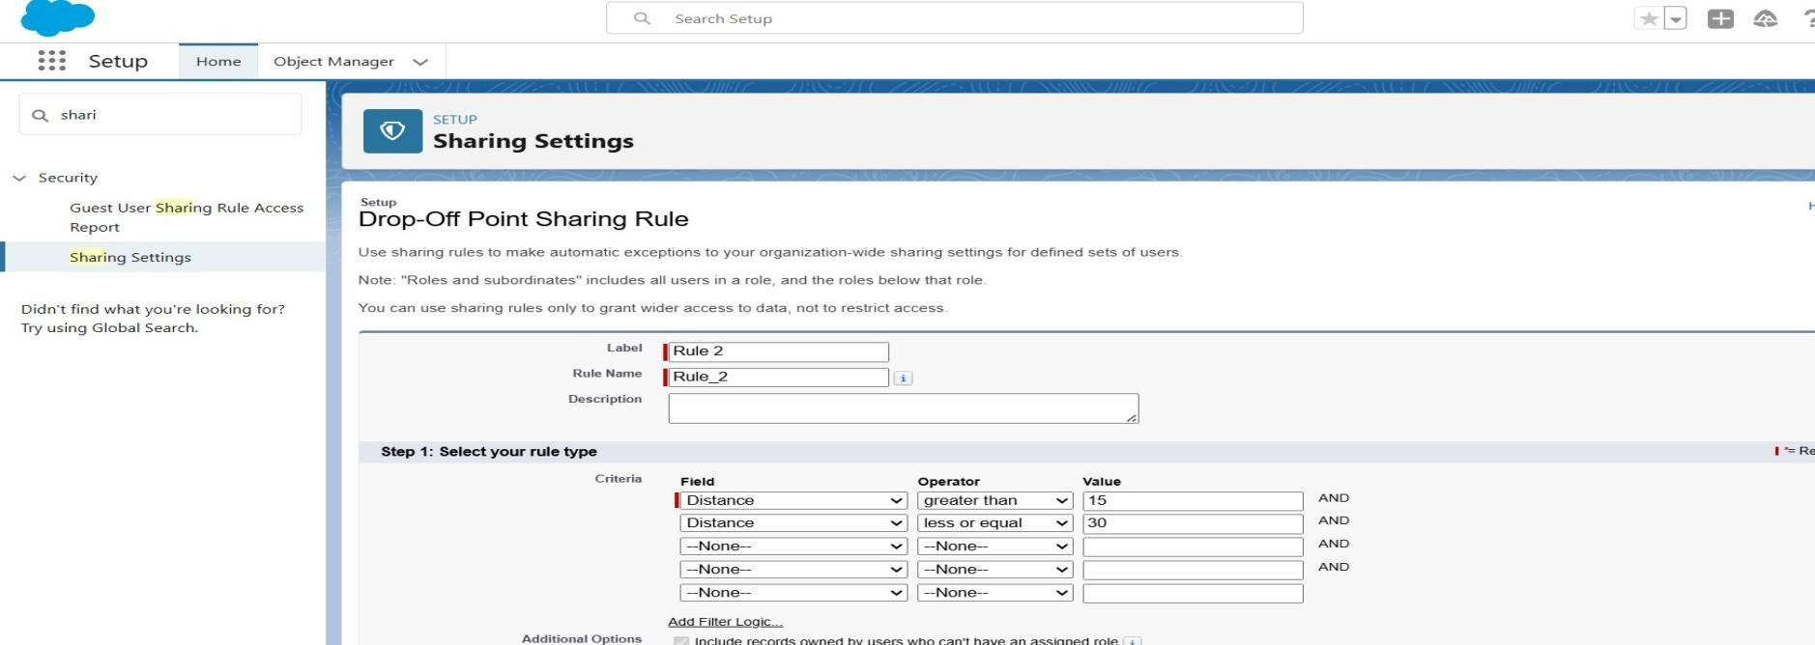Creationofsharingrules1,2&3:

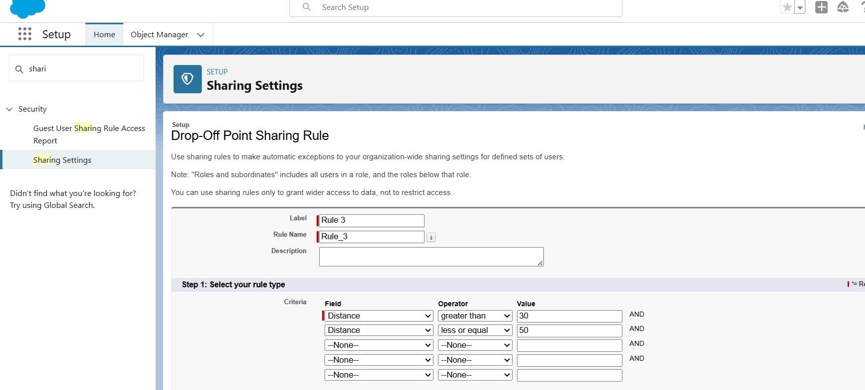

* Homepage :

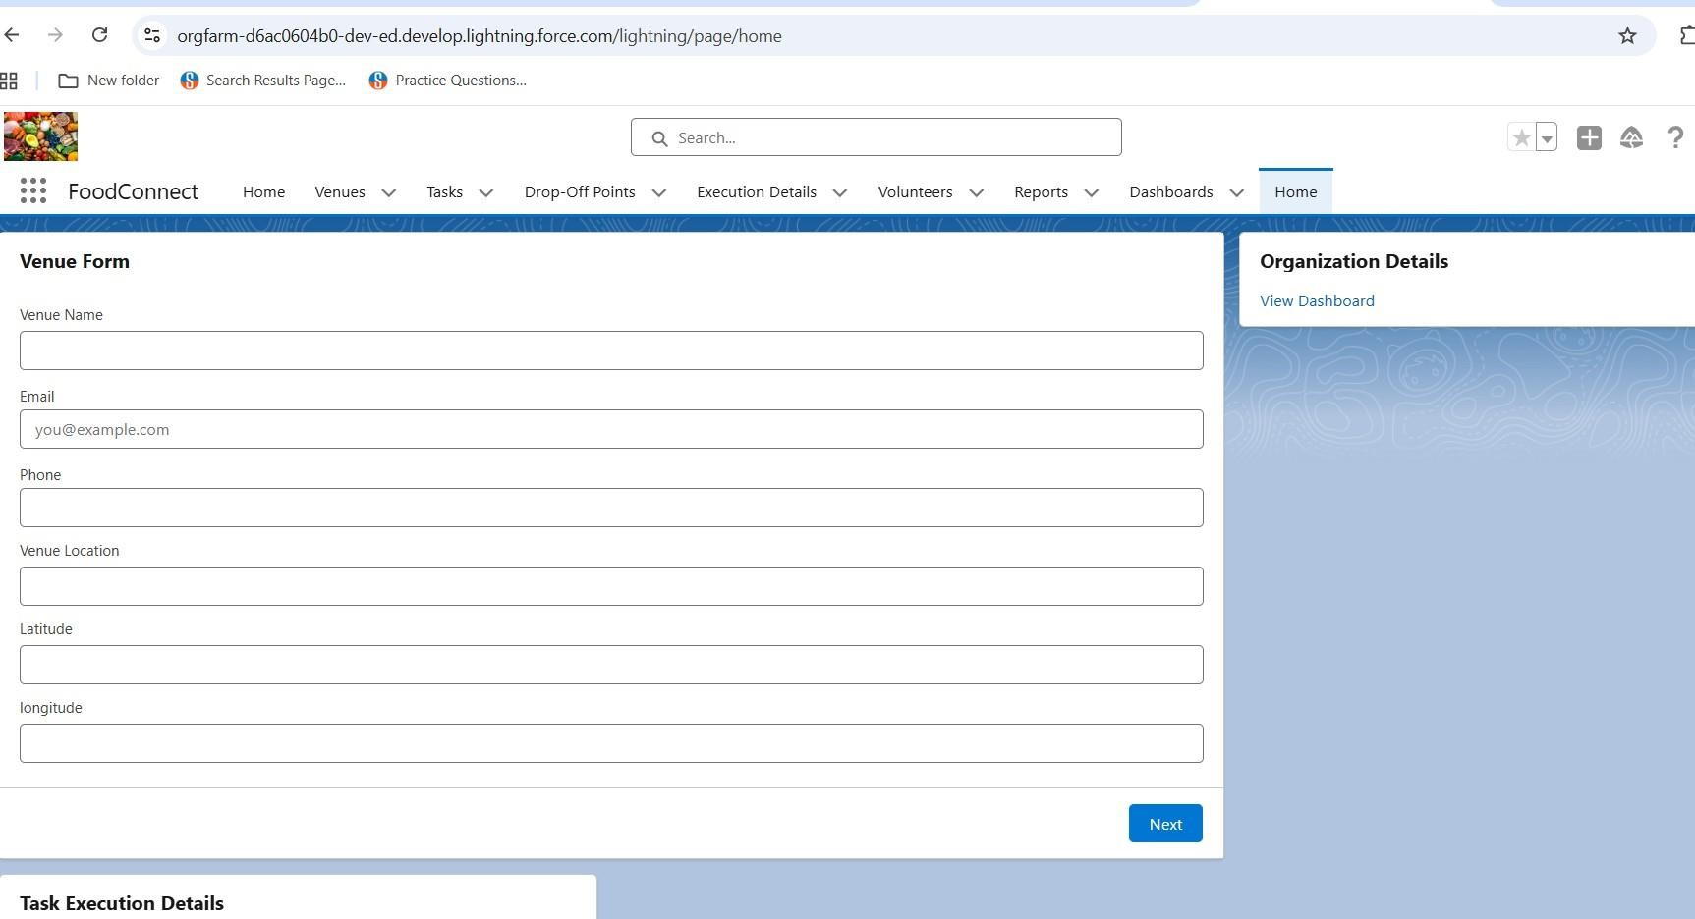

# Conclusion:

Supplyingleftoverfoodtothepoorreducesbothhungerandfoodwastage. It creates a bridge between surplus food sources and needypeople . The project encourages social responsibility and awareness in the community . This initiative can bring a positive impact towards a hunger free society.

Apextriggercodingfortosupplyleftoverfood to poor:

trigger Drop Off Trigger on Drop _ Off _point c(beforeinsert){

for(Drop _ Off_point c Drop : Trigger . new){

Drop . Distance c = Drop . distance_ calculation c;

}

}